During the meeting of the 06/05/2022 we highlighted 2 things: NetInterruptionResolutionRate(t)= InterruptionArrivalRate(t)-(Intpending(t)-Intpending(t0))/T Where T=t-t0

Intpending= Interruptionpending

Area of effective operation

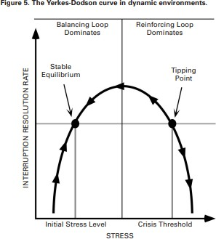

Safety Margin

# Paper 3: Complaint publicization in social media

1. How can complaint impact the financial returns of a firm? And their investors?
2. Context:

Studies across disciplines demonstrates that social media is an important source of information to investors impacting both retail and institutional investors.

They predict that the negative complaint-publicizing impact of firm responses outweighs their positive for two reasons:

* 1. Complaint are on the top’s firms social medias page so it could potentially increase their public exposure.
  2. It’s generated by consumer’s that have more credibility for negative content and diagnoscity of consumer-initiated information.

Consistent with this idea previous research has shown that exposure to consumer complaints negatively impacts other’s consumer’s attitudes about a firm.

According to the “negatively spiral” effect, complaints lead to more complaints.

An increasing volume of complaints can turn the firm’s social media page into a perpetual complaint arena, which encourages further complaints leading to a vicious cycle.

This could grab investor’s attention due to the virality of negative content. Investors increasingly monitor firm-related social media conversations and consumers sentiments through social media aggregators service.

Drawing these reasons, they hypothesize:

**H1**: Firm responses to complaints on platforms with complaints-publicizing features negatively impact firm values.

The negative content of a complaint about a firm can, in fact conflict with the content of the firm’s own tweets, especially because many firms tweets use promotional language to build positive image.

**H2**: Firm responses to complaints on platforms with complaints-publicizing features diminish the positive impact of the firm’s post on firm value.

Moreover, we argued that complaint publicization underlies the negative impacts of firm’s responses to complaints:

**H3**: Compared with a response strategy that engenders a lower level of complaint publicization, a response strategy that engenders a higher level of complaint publicization more negatively impact firm values.

**H4**: Compared with a response strategy that engenders a lower level of complaint publicization, a response strategy that engenders a higher level of complaint publicization more strongly diminishes the positive impact of the firm’s posts on firm value.

They made 2 study:

**Study 1**: Observational study that explores the impact of firm’s responses to complaints of firm’s value (Tobin’s Q perceived brand quality) and the effectiveness of the brand’s own posts. This study tests H1 and H2.

**Study 2**: Quasi experimental approach, allows for better identification of the impact of complaint publicization. This study test H3 and H4.

The studies are mutually informing. The first study provides higher external validity (375 S&P firms). The second study better experimental control, albeit in a smaller set of 107 firms in a more limited set of industries.

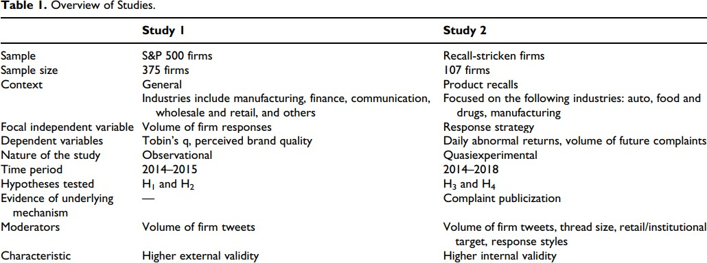

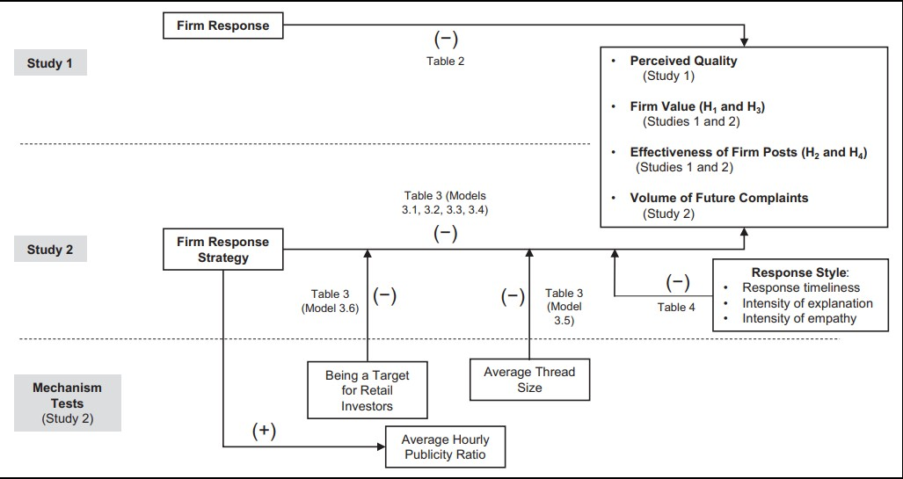

**Sample & Data:**

They choose the S&P 500 listed firm’s data index in 2014, and they identified 375 firms with an official twitter firms page.

They developed a python engine for web scrapping to collect information on twitter. Then after they downloaded all the communication’s firms on each firms, they categorized in two categories: tweets and firms responses.

The independent variables are the volume of firms tweets and the volume of firms responses aggregated into quarterly counts.

The dependent variable is quarterly Tobin’s q.

Tobin’s q: Forward looking market value measure that capture short/long term prospects of a firm.

It’s the most widely measure used for capturing changes in the value of a firm’s intangible assets, such as the equity that can be derived from the firm’s social media communications.

They also used controlled variables for the volume of WOM, average length of firm tweets, advertising intensity, research & development intensity (R&D), competitive intensity, industry size, return on assets, financial leverage, organizational slack, cost of goods sold, and quarter dummies. The final dataset included 2948 observations over eight quarters.

# Study 1:

It utilizes the S&P 500 firms twitter communications, brand equity, financial, and accounting data to test H1 and H2.

This study explores whether the volume of firm’s responses on twitter negatively impacts perceived quality and Tobin’s q and whether diminishes the impacts of the firm’s own tweets.

They choose twitter for 3 main reasons:

-platform with complaint-publicizing features

-Investors reacts more strongly to communications on twitter than any others social media platforms.

-Main social media outlets for complaining and complaint handling.

# Model Development & Estimation:

They estimated the following equation to test the impact of firm responses (Tobin’s q):

(1)

Where:

-i represents the firm

-t represents the quarter

-Y is the tobin’s Q

1, 2 represents the main effects of the volume of firm’s tweets (1) and the volume of firm’s responses (2).

3 represents the interaction between the volume of firm’s tweets and the volume of firms responses.

-4 represents the effects of the vector of control variables.

- represents the error term

So, before they test the model they used the Dickey-Fuller unit root test to determine whether any variable exhibited nonstationary behavior. The test identified that on R&D intensity has evolving so they included the first difference of this variable in the model. They also standardized the variables to help in interpretation and to reduce the possible collinearity.

To address endogeneity concerns, they estimated their model using a control function approach.They applied this to approach the possible endogeneity of the volume of firms tweets, volume of firms responses, volume of WOM, and advertising intensity.

First a separate estimation is made for each endogenous variable. In their case it’s means four estimations for the four potentially endogenous variables.

In each of the four estimations the endogenous variable is regressed on the set of the control variables of the equation 1, as well as a variable that correlates with the endogenous variable but does directly correlate with the unobserved drivers of firm’s values.

Secondly the predicted residuals from these four estimations are included in the main regression model.

So, this approach enables to estimate unbiased coefficients and mitigate endogeneity concerns.

To identify variables that satisfy these conditions they used the average volumes of tweets (responses) by peer firms as the instrumental variables.

For firm i in industry j (includes Nj firms) they calculated this variable as the sum of the volume of firm’s tweets (responses) by the firm’s industry j, other than firm I, divided by Nj-1.

They believe also that industry’s variable communication is a good instrumental variable for two reasons:

1. Peer firm’s behavior can have a normative effect, especially because peer firm face similar market conditions.
2. Peer firms are likely to imitate their peers

Thus, an industry-based instrumental variable is relevant.

They also used the average volume of WOM, and the average advertising intensity in a firm’s industry as instruments for the volume of WOM and the advertising intensity.

So, they estimated these four equations (with the control function approach):

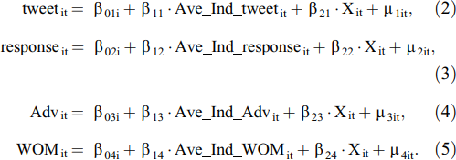

With:

i represent firm specific heterogeneity with regards to the volume of firms tweets

i represent firm specific heterogeneity with regards to the volume of firms responses

i represent firm specific heterogeneity with regards to the volume of advertising intensity

i represent firm specific heterogeneity with regards to the volume of WOM

 captures the impact of the industry’s average volume of firm’s tweets

 captures the impact of the industry’s average volume of firm’s responses

 captures the impact of the industry’s average volume of advertising intensity

 captures the impact of the industry’s average volume of WOM



Captures the effect of a vector of control variables







it

it

Random error terms

it

it

After estimating these four equations they estimated the sixth equation:

Where:

 represents the vector that captures the effect of these four predicted results.

# Study 2: Role of complaint Publicization

Study 1 provides evidence of the negative impact of a firm response on perceived quality, firm value and the effectiveness of a firm’s own posts (providing support of H1 and H2 that we will see later in the results).

However, this study has several shortcomings. Although that they control an extensive list of variables one might argue that the observed negative impact on firm value is driven by other factors for which the study did not control (for instance a higher volume of complaints can decrease firm value).

Secondly the study 1 didn’t provide direct evidence of the role of complaint publicization as the proposed underlying mechanism behind the negative impacts of firm’s responses.

And finally, the Tobin’s Q (main dependent variable) has been criticized by recent research.

Study 2 has been designed to address these issues by employing an alternative dependent variable that can increase confidence in these findings.

The goal of the study 2 is it’s rules out the confounding impact of firm fundamentals and captures the nature and the impact of complaint publicization.

The identification strategy for the second study entails a quasiexperiment in which they employ a strict regimen of matching (see Appendix B) to directly compare the impacts of two responses strategies that lead to differencial levels of complaint publicization. As such this study provides tests of H3 and H4.

Identification Settings: Products Recalls

One of the best settings to study firm responses to complaints is in the context of product recalls. A product recall could lead to a spike in the volume of complaints. Appendix C illustrates how such incidents cause a spike in the volume of WOM (Panel A) and in the volume of complaints (Panel B) about the firms in the dataset.

Utilizing products recalls allows for clearer identification of the impact of complaint publicization because it allows them to account for the source of complaints and to objectively control for its severity. Employing products recalls as a complaint-inducing shock is that we can reasonably attribute complaints in the days following the shock to a known source.

They utilize these measures (CPSC, FDA, NHTSA) to their preanalysis matching to control for the severity of the underlying issue causing the complaints.

# Quasiexperimental design

They first collected sample of products recalls of US publicity traded firms from three major sources that report product recalls for the automobile, manufacturing, and food and drug industries (NHTSA, CPSC, FDA). Overall, they found 318 product recalls from 2014 to 2018 that were not accompanied by other confounding events within a ten-day window [-5d, +5d] around the recall announcement.

These data were supplemented with a proprietary data set that included daily social media communications of publicly traded firms in the United States for the same period.

In their sample 172 recalls belonged to firms in this group. Therefore, the focus of the study is on these 172 recalls belonging to 111 firms. They focused on tweets and responses to complaints of these firms in a ten-day window surrounding the recall.

Here the main independent variable is firm response strategy. In their analyses they compare firms that addressed more than 75% of consumer complaints using an open exchange strategy (treatment group) against a matched group of firms that received the same volume of complaints but addressed more than 75% using a closed-exchange response strategy (control group).

Moreover, they explore the interaction between the response strategy and a firm’s tweets. They also explore the interaction between response strategy and three responses style variables (response timeliness, intensity of explanation, intensity of empathy) in firm responses.

The main dependent variable is daily abnormal returns. In a subsequent analysis, we utilize the volume of future complaints as an alternative dependent variable.

# Identification strategy

Several aspects of our analyses serve to remove the impacts of extraneous variables. First, they employed a strict regimen of matching which at the cost of losing observations and power enabled them to better isolate the impact of response strategy and to ensure that extraneous variables do not drive the observed effects.

Firms in the treatment and control groups were matched based on the preshock value of a wide range of variables (see Appendix B). A matching with replacement was done using the nearest neighbor. Out of the 172 recalls in our sample, they couls match with replacement 107 recalls, and eliminated the rest.

Secondly, they control for a list of variables at the firm, complaint, and response levels during the event window (see Appendix A).

Thirdly, by removing preshock differences the DID estimation significantly attenuates any baseline differences between the control and treatment groups.

Fourth, the DID estimation removes the fixed effects of any firm-specific variable that does not change during the narrow temporal window of the analysis [-5d; +5d].

Fifth, they dropped observations with other major news within the event window. The impact of the type of product recall event is absorbed by removing fixed effects in their model.

As their show subsequenty, the treatment and control groups have parallel daily returns trends prior to the shock.

Model specification



Where

Y represents the daily abnormal returns for brand i at day t.

Open i represents the brand i employs an open/closed exchange response strategy Post t represents an indicator variable that is equal to 1 for day t after the recall (0 otherwise)

 represents the coefficients of interest that measures the difference between differences (DID) in daily abnormal returns before and after products recalls between the treatment and control groups.

i represent the control for brand

t represents the day fixed effects

it representsthe vector of time varying control variables

# Results Study 1 results:

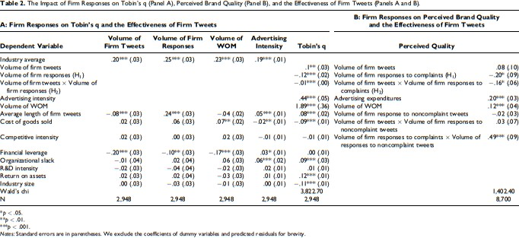

The results show a positive association between the volume of firm tweets and firm value

***(0.1)*** while the volume of firms’ responses is negatively associated with firm value ***(-0.12).***

-> ***Provide supports for H1.***

They find that the volume of firm responses diminishes the positive impact that the volume of firm tweets has on firm value. -> ***Provide supports for H2 (-0.16).***

# Study 2 results:

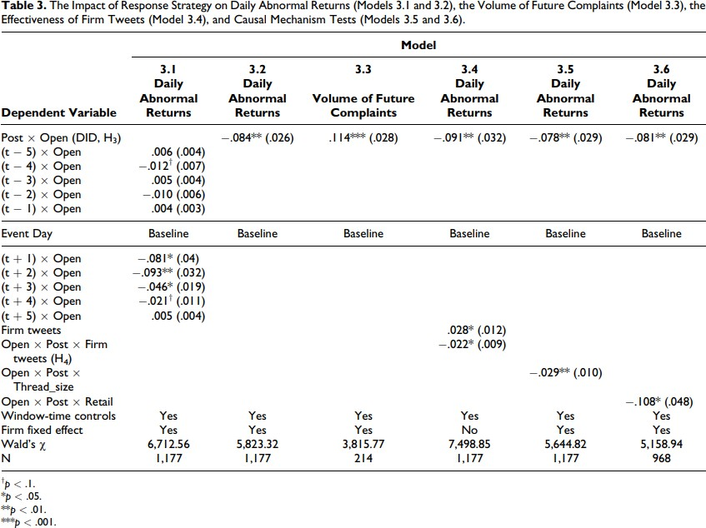

They observe that the firm that address complaints using an open-exchange response strategy have significantly lower abnormal returns in the days following the event compared with firms that employ a closed-exchange strategy. ***-> Provide support for H3***

They also find a negative three-way interaction indicating that when compared to a closed exchange strategy an open exchange strategy more strongly diminishes the positive’s impact of a firm’s tweet. ***-> Provide support for H4 (-0.022<0.028)***

# Impact of the results

These study shows how firm responses to complaints on a platform with complaint publicizing features can potentially lead to a host of adverse effects, ranging from diminished perceived quality, Tobin’s q, and daily abnormal returns to suppressed effectiveness of the firm’s own posts and increased volume of future complaints.

They find that these effects are stronger for firms that are trading targets for retail investors given that these investors rely on public information.

Also, they show that complaint publicization can influence investors in two important ways:

1. Negatively impact investors expectation of a firm’s future probability and success given its negative effect on consumers perceived quality.
2. It may engender a negativity spiral by encouraging more complaints which can impact the overall sentiment about the firm on the social media platform

They also show that a closedexchange response strategy may mitigate complaint publicization and its negative impacts. Specially employing a closed/open exchange strategy leads to firm responses to complaints positively/negatively impacting daily abnormal returns and reinforcing/diminishing the positive impact of firms’ posts.

Furthermore, when responses are timely and substantive a closed exchange strategy becomes even more effective.

# Contributions

-Their work contributes to the literature about online complaint handling by revealing how firm responses to complaints can negatively impact firm value and perceived quality and increase the volume of complaints.

They show that firm responses to complaints do not have a mitigating role to complaints on platforms such as twitter, where the visibility of complaints is changed by the firm’s responses to them.

-The current work adds a new element to the online complaint handling equation by revealing how a design feature of popular social media platforms such as Twitter leads to a hitherto-unknown phenomenon that we call “complaint publicization.” We show that firm responses to complaints on such platforms can impact the composition of a firm’s social media page, increasing the potential public exposure of complaints.

The findings also highlight the importance of considering platform-specific characteristics in social media research.

-The current work contributes to the literature on social media communications by documenting how firm responses to complaints can diminish the positive impact of a firm’s own posts. This finding highlight that the effects of social media communications can be more complicated than separate analyses of firm responses and firm posts would indicate.

-Our work provides empirical evidence that recalls cause a spike in the volume of complaints (Appendix C), and shows how using product recalls, along with sample matching, is a reasonable way to isolate the impact of firm responses to complaints. This approach allows for identifying the source of complaints.

# Critiques

This study shows us how a closed/open exchange Response strategy can impact daily returns of a firm and how the investors reacts with the feed in the social media.